CSE 219 — Signals and Linear Systems
Lec 8 · z-Transform: ROC, Inverse, Properties, LTI Systems
Lesson notes · Exam approach · TF practice with solutions · Quick notes (Ashraf Sir's portion)

How to Read These Notes
EXAM FOCUS | Exam importance, where it appears in the TF collection
MEMORIZE | Rules, tables and formulas to memorize
TRAP | Common mistakes and exam traps
EXAM-READY ANSWER | Model wording you can write in the exam
NOTE | Extra explanation / clarification
Grey box, monospace | Code, worked tables, derivations and hand-drawn sketches
Centered grey box | Formula to remember / final numerical result
Purple heading / ✔ green | Practice questions / their solutions

Contents
Exam Map — What the TF Papers Ask — z-transform questions and their weight
Lesson 17 — Definition, ROC and Standard Transforms — z = e^{sT}, aⁿu[n], left-sided, finite sequences, ROC properties 1–9
Lesson 18 — The Inverse z-Transform — contour formula, partial fractions, power series (log)
Lesson 19 — Properties and LTI Systems — ROC and causality/stability, pole-zero plots, difference equations
Quick Notes — z-Transform — merged revision notes + key diagrams
NOTE Slide numbers are PDF page numbers of 8 - Z-Transform.pdf (47 pages, “Lec 8”); the printed slide number is one less. The deck mirrors the Laplace transform: right-sided ⇒ outside a circle, left-sided ⇒ inside, two-sided ⇒ an annulus; the unit circle plays the role of the jω-axis.

Exam Map — What the TF Papers Ask
Session (paper) | Questions answered by this note
2023-24 (CSE 219) | Q8(a) All possible ROCs of X(z) = (1+2z⁻¹−z⁻²)/(1−(11/6)z⁻¹+z⁻²−(1/6)z⁻³) (12) · Q8(b) Poles 1/3, 2/3, 2: ROC for right-sided, FT converges, FT diverges, left-sided (8) · Q8(c) z-transform of |n|(½)^{|n|}; pole-zero plot (10) · Q8(d) Laplace vs z-transform; why z for discrete time (5)
2022-23 (CSE 219) | Q1(a) z-transform and ROC of x[n] = aⁿu[n] (10) · Q3(a) x[n] = aⁿ, 0≤n≤N−1: show the ROC excludes z = 0 (10) · Q3(b) Derive the contour-integral formula of the inverse z-transform (10) · Q3(c) Inverse z-transform of log(1+az⁻¹), |z|>|a| (15)

EXAM FOCUS The z-transform appears only in the two newest CSE 219 papers, always in Ashraf's part: 2022-23 Q1(a), Q3 (35 marks) and 2023-24 Q8 (35 marks). Learn: aⁿu[n] with its ROC, the three ROCs of a rational X(z), partial fractions in z⁻¹, the unit-circle test for the DTFT, and the power-series method (log(1 + az⁻¹)).

Lesson 17 — Definition, ROC and Standard Transforms
Lec 8 sl. 4–26
zⁿ is the eigenfunction of discrete LTI systems: y[n] = H(z)zⁿ with H(z) = Σh[k]z^{−k}. Sampling e^{st} at t = nT gives (e^{sT})ⁿ, so z = e^{sT} = e^{σT}e^{jωT} = re^{jθ} (sl. 6): the jω-axis maps to the unit circle |z| = 1, the left half-plane to the interior, a vertical strip to an annulus; s and s + j2π/T give the same z, which is why z is used for sequences (sl. 7–8).
X(z) = Σ_{n=−∞}∞ x[n]z^{−n} X(re^{jω}) = F{x[n]r^{−n}} (r = 1: DTFT)
The DTFT exists iff the ROC contains the unit circle |z| = 1
Sequence | X(z) | ROC
aⁿu[n] | 1/(1 − az⁻¹) = z/(z − a) | |z| > |a| (pole a, zero 0; exterior of a circle)
−aⁿu[−n−1] | 1/(1 − az⁻¹) | |z| < |a| (same expression, interior)
7(1/3)ⁿu − 6(1/2)ⁿu | z(z − 2/3)/((z − 1/3)(z − 1/2)) | |z| > 1/2
(1/3)ⁿ sin(πn/4)u[n] | (√2/6)z⁻¹/(1 − (√2/3)z⁻¹ + z⁻²/9) | |z| > 1/3
δ[n]; δ[n−1]; δ[n+1] | 1; z⁻¹; z | all z; all z ≠ 0; all finite z
aⁿ, 0 ≤ n ≤ N−1 | (1 − aᴺz⁻ᴺ)/(1 − az⁻¹) = z(1 − aᴺz⁻ᴺ)/(z − a) | all z ≠ 0; N−1 zeros on |z| = a at ae^{j2πk/N}
b^{|n|}, 0 < b < 1 | (1−b²)/((1−bz⁻¹)(1−bz)) | b < |z| < 1/b (no ROC if b > 1)

MEMORIZE A z-transform = expression + ROC. Geometric series: Σ(az⁻¹)ⁿ = 1/(1 − az⁻¹) for |az⁻¹| < 1. Left-sided: −Σ_{m≥1}(a⁻¹z)^m = 1/(1 − az⁻¹) for |z| < |a|.

ROC Properties (sl. 17–26)
# | Property
1 | ROC is a ring centred at the origin (depends on r = |z| only)
2 | ROC contains no poles (poles bound it)
3 | Finite-duration x ⇒ ROC = all z except possibly z = 0 (samples at n > 0 give z^{−n}) and/or ∞ (samples at n < 0). N₁ ≥ 0 ⇒ ∞ included; N₂ ≤ 0 ⇒ 0 included
4 | Right-sided ⇒ exterior of a circle |z| > r₀ (includes ∞ iff causal)
5 | Left-sided ⇒ interior 0 < |z| < r₀ (includes 0 iff anti-causal)
6 | Two-sided ⇒ annulus r₁ < |z| < r₂ (or empty)
7–9 | Rational: bounded by poles or reaching 0/∞; right-sided ⇒ outside the outermost pole; left-sided ⇒ inside the innermost non-zero pole

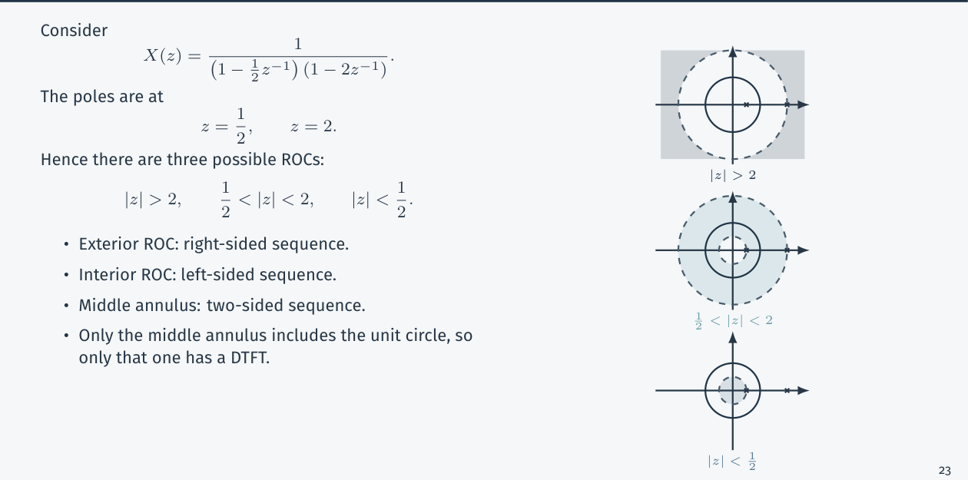
Figure 17.1 — Three ROCs of one X(z): exterior (right-sided), annulus (two-sided, has a DTFT), interior (left-sided) (Lec 8, sl. 26)

Exam Approach
1. Write the geometric series that defines X(z) and state the convergence condition — that is the ROC.
2. For a finite sequence: list the powers of z; positive powers (n < 0) exclude ∞, negative powers (n > 0) exclude 0.
3. For X(z) = N/D: poles = roots of D (in z, not in z⁻¹!); possible ROCs = regions separated by the pole circles.
4. State which ROC contains |z| = 1 (⇒ DTFT exists).

Practice — Lesson 17
(a) Actual — CSE 219 2022-23 Q1(a), Q3(a). (b) Actual — CSE 219 2023-24 Q8(a), Q8(d).
(a) (i) z-transform and ROC of x[n] = aⁿu[n]. (ii) x[n] = aⁿ for 0 ≤ n ≤ N − 1: show that the ROC of X(z) cannot include the origin. (10 + 10)
(b) Find all possible two-sided... sequences with X(z) = (1 + 2z⁻¹ − z⁻²)/(1 − (11/6)z⁻¹ + z⁻² − (1/6)z⁻³): for each, the ROC and x[n]. Differentiate the Laplace and z-transforms and say why z is preferred for discrete time. (12 + 5)

✔ Solution
(a)(i) X(z) = Σ_{n=0}^{∞} aⁿz^{−n} = Σ(az⁻¹)ⁿ = 1/(1 − az⁻¹) = z/(z − a), |az⁻¹| < 1 ⇔ |z| > |a|
pole z = a, zero z = 0; ROC outside the circle through the pole; contains |z| = 1 iff |a| < 1.
(ii) X(z) = Σ_{n=0}^{N−1} aⁿz^{−n} = 1 + az⁻¹ + a²z⁻² + … + a^{N−1}z^{−(N−1)}. For N ≥ 2 the term a z⁻¹ → ∞ as z → 0
(|z|⁻¹ → ∞), so X(0) is not finite ⇒ z = 0 cannot belong to the ROC. The sum is finite for every z ≠ 0,
so ROC = |z| > 0. (Closed form: X = z(1 − aᴺz⁻ᴺ)/(z − a): N−1 poles at the origin; the pole at z = a is
cancelled by a zero.)

(b) Denominator: z³ − (11/6)z² + z − 1/6 = (z − 1)(z − 1/2)(z − 1/3) ⇒ poles 1, 1/2, 1/3
X = 6/(1 − z⁻¹) − 3/(1 − ½z⁻¹) − 2/(1 − ⅓z⁻¹) [x[0] = lim X = 1 = 6 − 3 − 2 ✓]
Four ROCs (rings between the pole circles); poles inside the ROC's inner side give right-sided terms:
(1) |z| > 1 : x[n] = [6 − 3(1/2)ⁿ − 2(1/3)ⁿ] u[n] right-sided, causal
(2) 1/2 < |z| < 1 : x[n] = −6u[−n−1] − 3(1/2)ⁿu[n] − 2(1/3)ⁿu[n] two-sided
(3) 1/3 < |z| < 1/2: x[n] = −6u[−n−1] + 3(1/2)ⁿu[−n−1] − 2(1/3)ⁿu[n] two-sided
(4) |z| < 1/3 : x[n] = −6u[−n−1] + 3(1/2)ⁿu[−n−1] + 2(1/3)ⁿu[−n−1] left-sided
Rule: a pole on the inner side of the ROC (|p| < |z|) → right-sided term Apⁿu[n];
a pole on the outer side (|p| > |z|) → left-sided term −Apⁿu[−n−1].
The pole at z = 1 lies on the unit circle, so |z| = 1 belongs to no valid ROC: the DTFT of none of the four exists.

(d) Laplace: continuous-time, X(s) = ∫x e^{−st}dt, s = σ + jω, ROC = vertical strips/half-planes, stability ↔ ROC ∋ jω-axis, rational in s. z-transform: discrete-time, X(z) = Σx[n]z^{−n}, z = re^{jω}, ROC = rings/exteriors/interiors, stability ↔ ROC ∋ unit circle, rational in z (or z⁻¹), related by z = e^{sT}. Why z for DT: the map s → e^{sT} is many-to-one (s and s + j2π/T give the same sequence e^{snT}), so the s-plane would count the same discrete signal infinitely often; z removes that redundancy, turns difference equations into algebraic ones, uses the finite sum Σx[n]z^{−n} (no integrals) and makes the unit circle the frequency axis.

Lesson 18 — The Inverse z-Transform
Lec 8 sl. 28–32

1. Contour Formula (sl. 28)
z = re^{jω} in the ROC: x[n]r^{−n} = (1/2π)∫_{2π} X(re^{jω})e^{jωn}dω (inverse DTFT)
multiply by rⁿ: x[n] = (1/2π)∫_{2π} X(re^{jω})(re^{jω})ⁿ dω
z = re^{jω} ⇒ dz = jz dω ⇒ dω = dz/(jz):
x[n] = (1/2πj) ∮_C X(z) z^{n−1} dz (C: counter-clockwise circle inside the ROC; evaluate by residues)

2. Partial Fractions (sl. 29–31)
X(z) = (3 − (5/2)z⁻¹)/((1 − ¼z⁻¹)(1 − ⅓z⁻¹)) = 1/(1 − ¼z⁻¹) + 2/(1 − ⅓z⁻¹). ROC |z| > 1/3 ⇒ both right-sided: x = (¼)ⁿu[n] + 2(⅓)ⁿu[n]. ROC ¼ < |z| < ⅓: x = (¼)ⁿu[n] − 2(⅓)ⁿu[−n−1]. ROC |z| < ¼: both left-sided: −(¼)ⁿu[−n−1] − 2(⅓)ⁿu[−n−1]. The expansion never changes; the ROC decides each term.

3. Power Series (sl. 31–32)
The coefficient of z^{−n} is x[n] (positive powers of z are negative times). 4z² + 2 + 3z⁻¹ ⇒ 4δ[n+2] + 2δ[n] + 3δ[n−1]. 1/(1 − az⁻¹) = 1 + az⁻¹ + a²z⁻² + … (|z| > |a|) ⇒ aⁿu[n]; for |z| < |a| expand in z/a ⇒ −aⁿu[−n−1].
X(z) = log(1 + az⁻¹), |z| > |a|: log(1 + v) = Σ_{n≥1} (−1)^{n+1}vⁿ/n (|v| < 1), v = az⁻¹ (|v| < 1 ⇔ |z| > |a|)
X(z) = Σ_{n≥1} (−1)^{n+1} (aⁿ/n) z^{−n} ⇒ x[n] = (−1)^{n+1} aⁿ/n for n ≥ 1, 0 for n ≤ 0
i.e. x[n] = (−1)^{n+1}(aⁿ/n) u[n − 1] (checked numerically: Σ ... = log(1 + a/|z|))

Exam Approach
1. Rational X: partial fractions in z⁻¹ (write with unit constant terms), then use the ROC for each term.
2. Log/irrational X: expand in a power series of z⁻¹ valid in the ROC (|…| < 1) and read off the coefficients.
3. Check x[0] = lim_{z→∞}X(z) for causal sequences.

Practice — Lesson 18
(a) Actual — CSE 219 2022-23 Q3(b), Q3(c). (b) Practice set 11.1–11.5 (first two).
(a) Derive the contour-integral formula for the inverse z-transform; find the sequence for X(z) = log(1 + az⁻¹), |z| > |a|. (10 + 15)
(b) Invert (2 − z⁻¹)/((1 − ¼z⁻¹)(1 − ¾z⁻¹)), |z| > ¾; and 1/((1 − 2z⁻¹)(1 − ⅓z⁻¹)), 1/3 < |z| < 2.

✔ Solution
(a) Derivation and the logarithm series in the boxes above (the log series needs |az⁻¹| < 1, which is exactly the ROC |z| > |a|).
(b) (2 − z⁻¹)/((1 − ¼z⁻¹)(1 − ¾z⁻¹)) = 1/(1 − ¼z⁻¹) + 1/(1 − ¾z⁻¹) [A = (2−4)/(1−3)=1, B = (2−4/3)/(1−1/3)=1]
|z| > 3/4: x[n] = [(¼)ⁿ + (¾)ⁿ] u[n]
1/((1−2z⁻¹)(1−⅓z⁻¹)) = (6/5)/(1 − 2z⁻¹) − (1/5)/(1 − ⅓z⁻¹) [A = 1/(1−1/6) = 6/5, B = 1/(1−6) = −1/5]
1/3 < |z| < 2: the pole 2 is outside ⇒ left-sided; pole 1/3 inside ⇒ right-sided:
x[n] = −(6/5)2ⁿu[−n−1] − (1/5)(⅓)ⁿu[n]

Lesson 19 — Properties and LTI Systems
Lec 8 sl. 34–47
Property | Sequence | Transform | ROC
Linearity | ax₁ + bx₂ | aX₁ + bX₂ | ⊇ R₁ ∩ R₂
Time shift | x[n − n₀] | z^{−n₀}X(z) | R (except 0, ∞)
z-scaling | a₀ⁿx[n] | X(z/a₀) | |a₀|R
Reversal | x[−n] | X(z⁻¹) | R⁻¹
Conjugation | x*[n] | X(z) | R
Time expansion | x[n/k] (zeros between) | X(zᵏ) | R^{1/k}
Convolution | x₁ * x₂ | X₁X₂ | ⊇ R₁ ∩ R₂
First difference | x[n] − x[n−1] | (1 − z⁻¹)X | R (+ 0 deleted, z = 1 may be added)
Accumulation | Σ_{k≤n}x[k] | X/(1 − z⁻¹) | ⊇ R ∩ {|z| > 1}
z-differentiation | n x[n] | −z dX/dz | R
Initial value | x[n] = 0 for n < 0 | x[0] = lim_{z→∞}X(z)

Example 10.18: aⁿu[n] ↔ 1/(1 − az⁻¹) ⇒ n aⁿ u[n] ↔ −z d/dz[1/(1 − az⁻¹)] = az⁻¹/(1 − az⁻¹)².

LTI Systems (sl. 43–47)
- Y(z) = H(z)X(z); if the ROC contains |z| = 1, H(e^{jω}) is the frequency response.
- Causal ⇔ ROC is the exterior of a circle including ∞ (for rational H: outside the outermost pole, numerator degree ≤ denominator degree in z).
- Stable ⇔ ROC contains the unit circle. Causal + rational: stable ⇔ all poles inside |z| = 1.
- H = 1/(1 − 2r cos θ z⁻¹ + r²z⁻²): poles re^{±jθ}; causal ⇒ stable iff r < 1.
- Difference equation Σaₖy[n−k] = Σbₖx[n−k] ⇒ H(z) = Σbₖz^{−k}/Σaₖz^{−k}; the equation gives the expression, not the ROC (causality chooses it).
- Ex 10.25: y[n] − ½y[n−1] = x[n] + ⅓x[n−1] ⇒ H = (1 + ⅓z⁻¹)/(1 − ½z⁻¹); step response (|z| > ½): Y = H/(1 − z⁻¹) = (8/3)/(1 − z⁻¹) − (5/3)/(1 − ½z⁻¹) ⇒ y[n] = (8/3)u[n] − (5/3)(½)ⁿu[n].
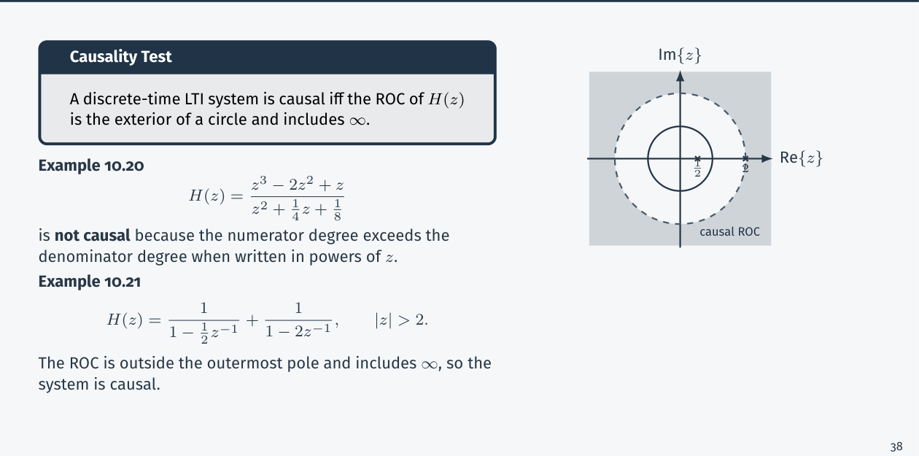
Figure 19.1 — Causality and stability from the ROC of H(z) (Lec 8, sl. 44)
TRAP • Poles are roots in z: 1 − (11/6)z⁻¹ + z⁻² − (1/6)z⁻³ = 0 ⇔ z³ − (11/6)z² + z − 1/6 = 0. • The ring that contains the unit circle is the only one with a DTFT. • ROC of a sum can exceed the intersection if poles cancel. • Left-sided/anti-causal sequences use u[−n − 1] with a minus sign.

Exam Approach
1. Identify the pole radii; list the rings.
2. Right-sided → outside the largest pole; left-sided → inside the smallest; DTFT exists ⇔ unit circle in the ROC.
3. For |n|bⁿ-type sequences split n ≥ 0 and n < 0, transform each, intersect the ROCs (a ring).

Practice — Lesson 19
(a) Actual — CSE 219 2023-24 Q8(b), Q8(c). (b) Practice set 12.1, 12.4.
(a) (i) Fig. 2 shows the pole-zero plot of Y(z) (poles at 1/3, 2/3 and 2). What can be said about the ROC if: (i) y[n] is right-sided; (ii) the FT of y[n] converges; (iii) the FT does not converge; (iv) y[n] is left-sided? (8) (ii) z-transform and pole-zero plot of x[n] = |n|(1/2)^{|n|}. (10)
(b) H(z) = (1 − 2z⁻¹)/((1 − ½z⁻¹)(1 − 2z⁻¹)): valid ROCs, causality, stability and DTFT; h[n] = (2/3)ⁿu[n] − (4/3)ⁿu[−n−1]: H(z), ROC, causal? stable? DTFT?

✔ Solution
(a)(i) right-sided ⇒ ROC is the exterior of the outermost pole: |z| > 2
(ii) FT converges ⇔ ROC contains |z| = 1 and no pole: 2/3 < |z| < 2
(iii) FT does not converge ⇔ the ROC excludes |z| = 1: |z| > 2, or |z| < 1/3, or 1/3 < |z| < 2/3
(iv) left-sided ⇒ interior of the innermost pole: |z| < 1/3

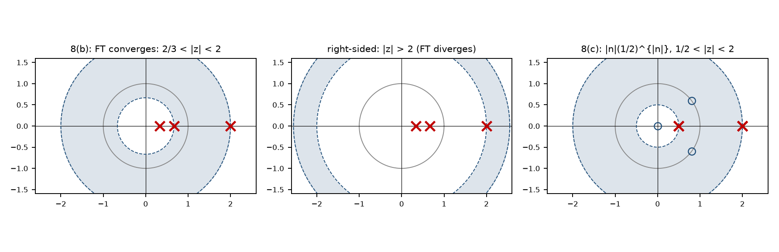
Figure 19.2 — Pole-zero plots with the ROC shaded: 8(b)(ii), 8(b)(i), and 8(c)
(ii) x[n] = |n|aⁿ-type, a = 1/2: for n ≥ 0: n(½)ⁿu[n] ↔ ½z⁻¹/(1 − ½z⁻¹)², |z| > ½
for n < 0: x[n] = (−n)(½)^{−n} = (−n)2ⁿ = m(½)^m with m = −n ≥ 1: Σ_{m≥1} m(½)^m z^{m} = ½z/(1 − ½z)², |z| < 2
X(z) = ½z⁻¹/(1 − ½z⁻¹)² + ½z/(1 − ½z)² = 2z(5z² − 8z + 5)/((z − 2)²(2z − 1)²), ½ < |z| < 2
poles: z = ½ (double), z = 2 (double); zeros: z = 0 and z = 0.8 ± 0.6j (on the unit circle, 5z² − 8z + 5 = 0)
the ROC is an annulus containing |z| = 1 ⇒ the DTFT exists. Check: X(1) = 4 = Σ|n|(½)^{|n|} ✓

(b) H = (1 − 2z⁻¹)/((1 − ½z⁻¹)(1 − 2z⁻¹)): the zero at z = 2 cancels the pole at z = 2 ⇒ H = 1/(1 − ½z⁻¹)
cancelling: H = 1/(1 − ½z⁻¹) with ROC |z| > ½ (causal; contains the unit circle ⇒ stable, DTFT exists) or |z| < ½
(anti-causal, unstable). Without cancelling, the rings are |z| > 2, ½ < |z| < 2, |z| < ½ (the 2-pole counts as a boundary).
h[n] = (2/3)ⁿu[n] − (4/3)ⁿu[−n−1]: H = 1/(1 − (2/3)z⁻¹) + 1/(1 − (4/3)z⁻¹), ROC 2/3 < |z| < 4/3 (the two ROCs
overlap in a ring) ⇒ two-sided ⇒ non-causal; the ring contains |z| = 1 ⇒ stable and the DTFT exists.

Quick Notes — z-Transform
Revision points for Lessons 17–19.

L17 · ROC
- X = Σx[n]z^{−n}; z = e^{sT}; DTFT ⇔ ROC ∋ |z| = 1.
- aⁿu ↔ 1/(1−az⁻¹), |z| > |a|; −aⁿu[−n−1], |z| < |a|; right → exterior, left → interior, two-sided → ring.
- Finite sequence: all z except 0 (n > 0 terms) / ∞ (n < 0 terms).

L18 · Inverse
- x[n] = (1/2πj)∮X z^{n−1}dz; partial fractions in z⁻¹; pole inside the ROC's inner edge → right-sided term.
- log(1 + az⁻¹), |z| > |a| ⇒ (−1)^{n+1}aⁿ/n, n ≥ 1.

L19 · Systems
- Causal ⇔ exterior ROC incl. ∞; stable ⇔ ROC ∋ unit circle; causal + stable ⇔ poles inside |z| = 1.
- 8(a) 2023-24: poles 1, ½, ⅓: four ROCs; X = 6/(1−z⁻¹) − 3/(1−½z⁻¹) − 2/(1−⅓z⁻¹).
- 8(c): X = 2z(5z²−8z+5)/((z−2)²(2z−1)²), ½ < |z| < 2.

Key Diagrams to Reproduce
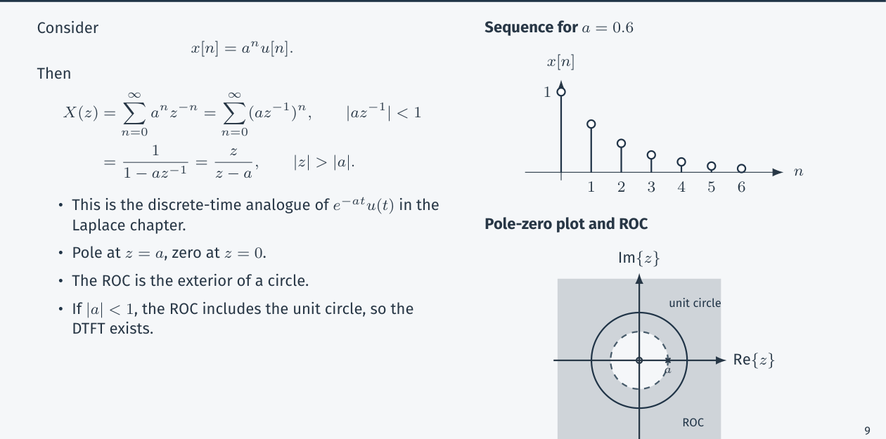
z-transform of aⁿu[n]: pole-zero plot and ROC (Lec 8, sl. 12)

